**Assignment 1 – Website Design (Dreamweaver CC or other editors)(Full Mark:80)**

|  |  |
| --- | --- |
| **Student Name: \_Valerio, Jericho T.\_\_\_\_\_\_** | **Class: \_\_1A\_\_\_\_\_\_\_\_** |

**Due Date: Feb 5, 2021 Submit your zipped website (named as YourNameAssignment1) to Moodle!!**

Download datafile: “**DataFileAssignment1**” from Moodle and text for the website stored in **“*MWDP­Website.txt”***

**Guidelines:**

**Section A (50%)**

1. Create a folder named as **YourNameAssignment1** for your site. (2%)

2. Define a new site. Use the site name **YourNameAssignment1**

You are required to create **4 HTML files** and 1 template file (index.html, comic.html, modelkit.html and wave.html are produced from a template file-YourName\_2020.html i.e. ChanTaiMan\_2020.html) as described below.

The site should be **well-organized** by putting material (eg. pictures) in appropriate folder(s).

3. For the index.html (use **table** or otherwise)

* Create a HTML file as in Figure1 and save it as **index.html** (2%)Change the **page title** of the index.html to **YourName.** (1%)
* Edit index.html file as Figure 1 shown (8%)

(i) Format the word “ Welcome to **Your Surname**’s WebSite” with Heading 1

(ii) Others font size 18px, font color green.

(iii) Insert two pictures as shown

(iv) The image has the following properties:

Your Full Name

|  |  |
| --- | --- |
| **Image** | **Link to Web Page** |
| enter | **comic.html** |

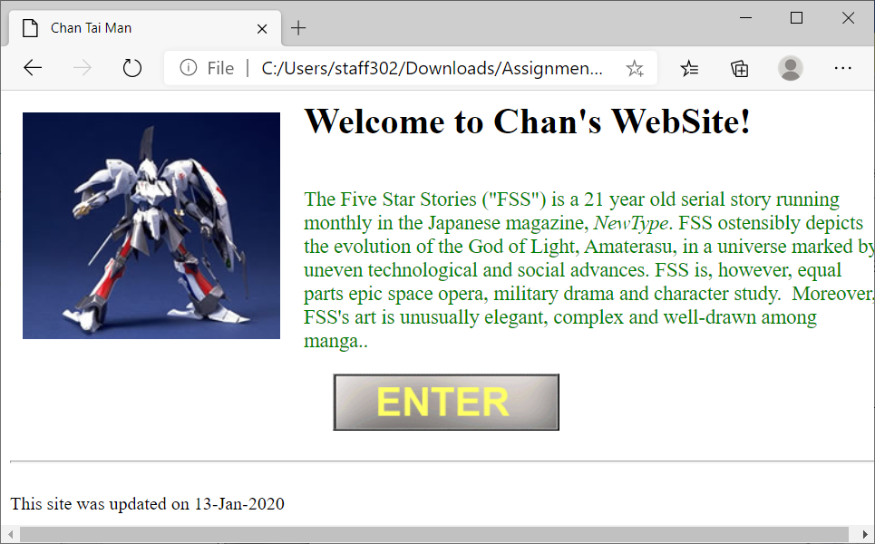

Figure 1  
index.html

Date created the webpage

Your Surname

4. Insert a horizontal rule after the ENTER icon as above. (2%)

5. Create an html file as template, **YourName\_2020.html** (If Dreamweaver is used and it will be **YourName\_2020.dwt)**

6. Edit YourName\_2020.html file as Figure 2 shown

(i) Use table(4 x 3) to create the template YourName\_2020.html and merge the cells as appropriate to have the layout as below (2%)

(ii) Insert 4 pictures as shown (4%)

(iii) Each image has the following properties: (3%)

|  |  |
| --- | --- |
| **Image** | **Link to Web Page** |
| home | **index.html** |
| comic | **comic.html** |
| modelkit | **modelkit.html** |

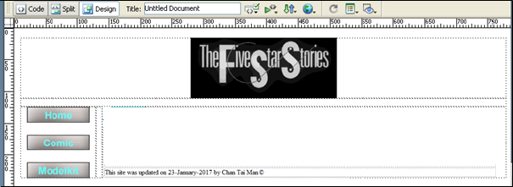

Your Name followed by special character © a

Top-align images in this column

Merge cells if necessary for well-displayed

Use date format as 13-Jan-2020

Figure 2 - YourName\_2020.html file

7. Use your template file to create a web page and save it as **comic.html**

8. Edit comic.html file as Figure 3 shown

(i) Change the page background color to #FFFFCC (light yellow) (2%)

(ii) Add two images and the image has the following properties: (5%)

|  |  |
| --- | --- |
| **Image** | **URL** |
| FSS Vol 1 | http://www.toyspress.co.jp  (Target – Blank  i.e. webpage in a New Window) |

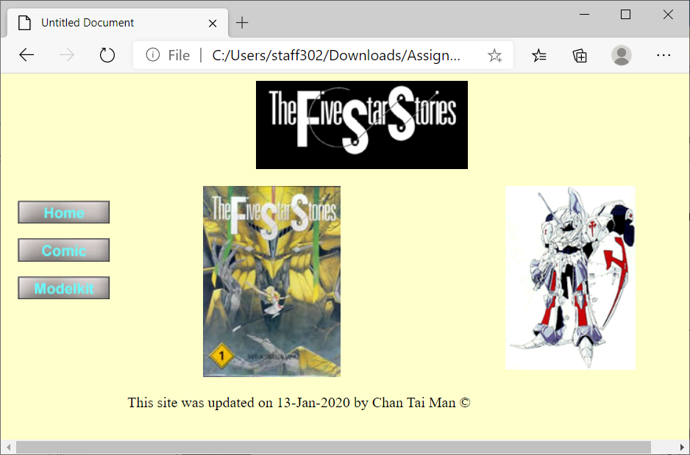

Figure 3 - comic.html

9. Use your template file to create a web page and save it as **modelkit.html**.

10. Edit modelkit.html file as Figure 4 shown

(i) Font size 24px, Bold for the word “Wave” (2%)

(ii) background picture : BACK124.GIF (5%)

(iii) The Word has the following properties: (5%)

|  |  |
| --- | --- |
| **Word** | **Link to Web Page** |
| Wave | **wave.html** |

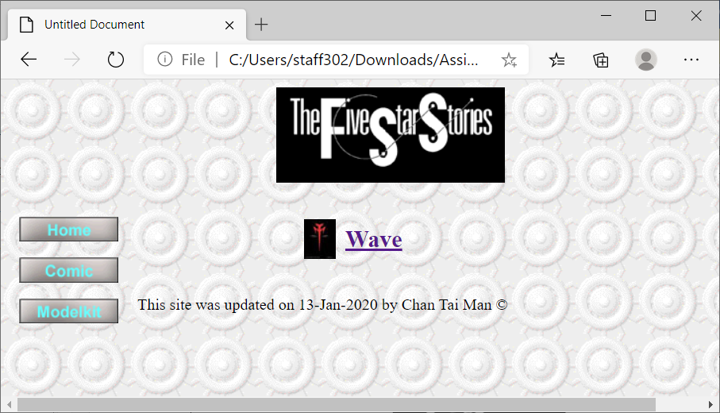

Bold and

24px in font size

Figure 4 - modelkit.html

11. Use your template file to create a web page and save it as **wave.html.**

12. Edit wave.html file as Figure 5 shown

(i) The image has the following properties: (5%)

|  |  |
| --- | --- |
| **Image** | **Run the Application** |
| wave_logo | <http://www.hobby-wave.com>  (Target – Blank) |

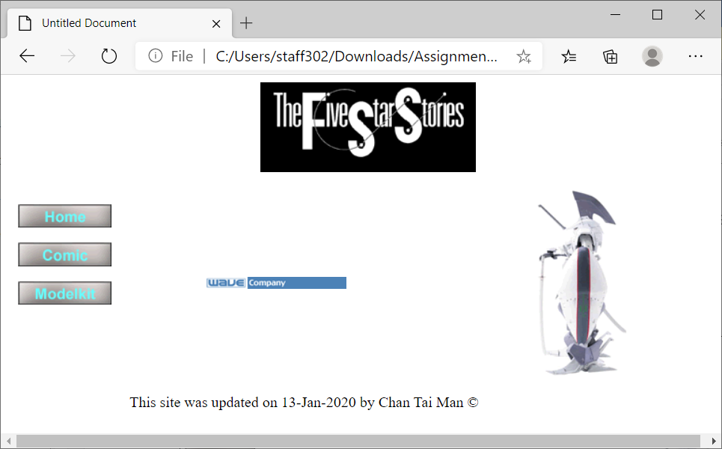

Figure 5 - wave.html

15. Save all Web Pages. (2%)

**Section B (30%)**

1. Create a new html file of your own and save it as **myPage.html**.
2. Design **myPage.html** with creativity and artistic design.
3. Hints to design **myPage.html**:

Theme, Graphics(pictures), layout, font, color coordination, etc.

1. Link to the website using index.html:

From index.html, when clicking the picture below, link to **myPage.html**.

From original home page, index.html

|  |  |
| --- | --- |
| **Image in index.html** | **Link to Web Page** |
|  | **myPage.html** |

1. Mark Distribution
2. Creativity DONE (10%)
3. Functions and Techniques used DONE (10%)
4. Template Done
5. Table Done
6. Hyperlink (Link to external Website, Bookmark) Done
7. CSS DONE
8. Use of Ordered/Unordered List
9. Picture, Audio, Video/Flash Animation DONE
10. Design (theme, graphics, layout, font, color coordination) Done (10%)

Zip the folder with all your html files, image and template files. Then submit the zipped file to Moodle.